1. Spring Security allows us to configure security based on authority and roles.
2. Let’s see what is authority and role.
3. **Authority**:
   1. This is single individual privilege or permission.
   2. These are the Authorities:
      1. CREATE
      2. READ
      3. UPDATE
      4. DELETE
   3. Using Authorities, we can restrict access in fined-grained control.
4. **Role**:
   1. Group of authorities/permissions/privileges.
   2. Our app may have requirement that we don’t want to go for authorities but role.
   3. We want roles such as
      1. Admin
      2. Normal User
      3. Supervisor
      4. Employer
      5. Employee
5. **NOTE**:
   1. Authority and Role names are up to you.   
      Either READ, READONLY
   2. The way how authorities and roles work are very similar in nature.

There is no difference how you configure authorities and roles except the method names.

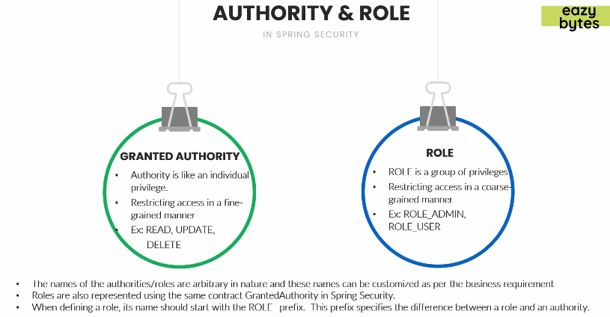  
Let’s see how to configure roles in DB as well as in Spring Security.